I would like 2 section contact info and product info:

Product type is 3 part ; aliminium veranda , glass sliding walls , other

If choose aliminium veranda It should ask wideness <300cm , 300 till 400cm, 400 till 500 cm

Dept and color  
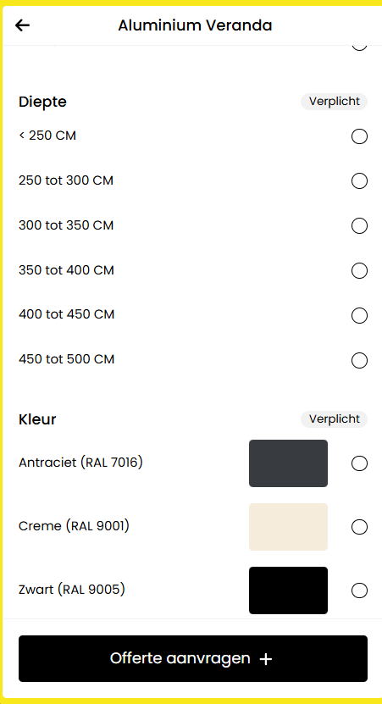

Ceiling, frontside, leftside,rightside, spie left, spie right, lightning

Glazen schuifwanden

